Calculator−free Solutions

1. (a) (i) ${}_{ }^{8}{P_{5}}$ or ${}_{ }^{8}{C_{5}}×5!$
(ii) ${}_{ }^{4}{C_{3}}×{}_{ }^{4}{C_{2}}×5!$

(b) (i) $6^{4}×5^{2}×6!$
(ii) ‘9’ from first set only: ${}_{ }^{5}{C_{3}}×{}_{ }^{4}{C_{2}}×6!$
‘9’ from second set only: ${}_{ }^{5}{C_{4}}×{}_{ }^{4}{C_{1}}×6!$
no ‘9’ chosen: ${}_{ }^{5}{C_{4}}×{}_{ }^{4}{C_{2}}×6!$
total $=\left({}_{ }^{5}{C_{3}}×{}_{ }^{4}{C_{2}}+{}_{ }^{5}{C_{4}}×{}_{ }^{4}{C_{1}}+{}_{ }^{5}{C_{4}}×{}_{ }^{4}{C_{2}}\right)×6!$ [8]

2. (a) (i) $i^{n+2}=i^{n}×i^{2}=-i×-1=i$
(ii) $i^{2n+1}={\left(i^{n}\right)}^{2}×i={\left(-i\right)}^{2}×i=-i$
(b) $\frac{1-i}{i+\frac{2}{i}}×\frac{i}{i}=\frac{i-i^{2}}{i^{2}+2}=\frac{1+i}{-1+2}=1+i$
(c) ${\left(1+i\right)}^{4}-{\left(1-i\right)}^{4}$
$=\left[{\left(1+i\right)}^{2}+{\left(1-i\right)}^{2}\right]×\left[{\left(1+i\right)}^{2}-{\left(1-i\right)}^{2}\right]$
$=\left[1+2i-1+1-2i-1\right]×\left[1+2i-1-1+2i+1\right]$
$=0×4i=0$ [7]

3. (a) $5^{3}=5+1×10×6+1×4×15=5+60+60=125$
(b) ${}_{ }^{5}{C_{2}} , {}_{ }^{4}{C_{1}}$
(c) $n^{3}=n+{}_{ }^{n-1}{C_{0}}×{}_{ }^{n+1}{C_{1}}×{}_{ }^{n}{C_{2}}+{}_{ }^{n}{C_{0}}×{}_{ }^{n-1}{C_{1}}×{}_{ }^{n+1}{C_{2}}$ [5]

4. (a) (i) $\left[\begin{matrix}0 & -1 & 1 \\ 1 & 1 & -1 \\ 1 & 1 & 0\end{matrix}\right]×\left[\begin{matrix}1 & 1 & 0 \\ -1 & -1 & 1 \\ 0 & -1 & 1\end{matrix}\right]=\left[\begin{matrix}1 & 0 & 0 \\ 0 & 1 & 0 \\ 0 & 0 & 1\end{matrix}\right]$

A and B are inverses of each other.

(ii) $\left[\begin{matrix}0 & -1 & 1 \\ 1 & 1 & -1 \\ 1 & 1 & 0\end{matrix}\right]×\left[\begin{matrix}x \\ y \\ z\end{matrix}\right]=\left[\begin{matrix}-6 \\ 8 \\ 3\end{matrix}\right]$
$\left[\begin{matrix}x \\ y \\ z\end{matrix}\right]={\left[\begin{matrix}0 & -1 & 1 \\ 1 & 1 & -1 \\ 1 & 1 & 0\end{matrix}\right]}^{-1}×\left[\begin{matrix}-6 \\ 8 \\ 3\end{matrix}\right]=\left[\begin{matrix}1 & 1 & 0 \\ -1 & -1 & 1 \\ 0 & -1 & 1\end{matrix}\right]×\left[\begin{matrix}-6 \\ 8 \\ 3\end{matrix}\right]=\left[\begin{matrix}2 \\ 1 \\ -5\end{matrix}\right]$
$∴x=2, y=1, z=-5$

4. (b) (i) T₁ performs a rotation of 180°
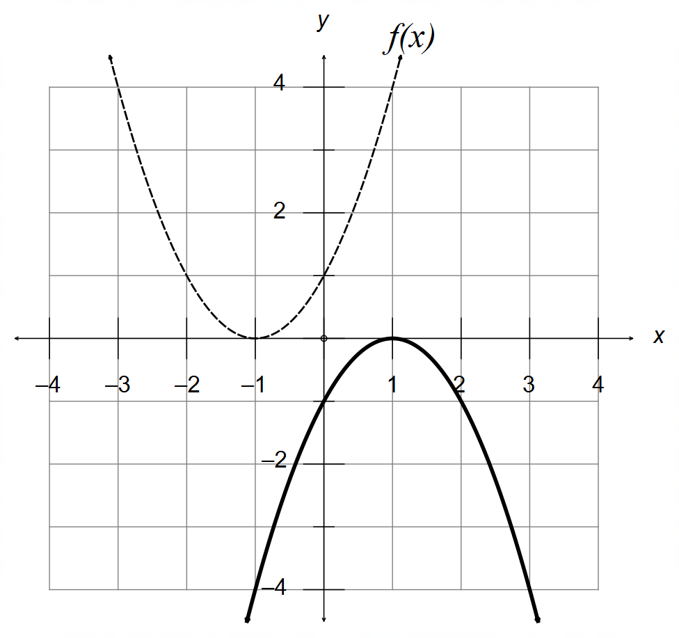

$∴y=-{\left(x-1\right)}^{2}$

(ii) Reflection of the line $y=x$
T₂$=\left[\begin{matrix}0 & 1 \\ 1 & 0\end{matrix}\right]$

(iii) New Area $=\left|T_{3}\right|×10\frac{2}{3}=6×\frac{32}{3}=64 units^{2}$ [12]

5. (a) (i) $y=-3\cos\left[4\left(x-\frac{π}{12}\right)\right]=-3\cos\left[4x-\frac{π}{3}\right]$
$∴ A=-3 ω=4 θ=-\frac{π}{3}$

(ii) $y=-3\sin\left(4x+\frac{π}{6}\right)$
(b)
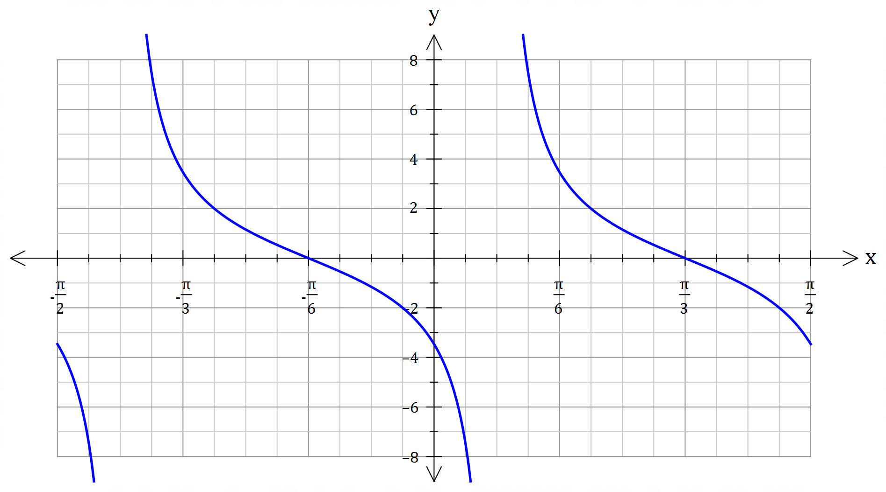
Scale factor
($y=2$ at $x=\frac{5π}{24}$)

Period of $\frac{π}{2}$

Vertical Asymptote
at $x=\frac{π}{12}$

[8]

6. (a) (i) $\sqrt{2}×\sqrt{8}=\sqrt{16}=4$
(ii) “If $ab$ is irrational, then both $a$ and $b$ must be irrational”

(b) A ⇒ B: If the triangle has two equal sides, then it is isosceles,
and therefore it has two congruent sides.
$∴$ A ⇒ B is valid and True.

B ⇒ A: If the triangle has two congruent sides, then it is isosceles,
and therefore it has two equal sides.
$∴$ B ⇒ A is valid and True.

$∴$ A ⇔ B

(c) $∀x∈P, ∃ y∈ P :xy∈Q$ [6]

7. Assume $n$ is even and that $n^{3}$ is odd.
Let $m∈N:n=2m$ is even.
$n^{3}={\left(2m\right)}^{3}=8m^{3}=2\left(4m^{3}\right)$
Since $n^{3}$ cannot be both even and odd simultaneously, then this
is a contradiction. And therefore $n$ must be odd. [4]

